Assessment task 2

Ciarán Maher 17/11/2015
Feasibility Report

Contents
Contents 2
Feasibility Report 3
Definition 3
Components 3
Product 3
Technical 3
Financial 4
Operational 5
Political 6
Alternative Solutions 6
Recommendations 7
Bibliography 8

Feasibility Report

Definition
A feasibility study aims to objectively and rationally uncover the strengths and weaknesses of an existing business or proposed venture, opportunities and threats present in the environment, the resources required to carry through, and ultimately the prospects for success. In its simplest terms, the two criteria to judge feasibility are cost required and value to be attained.

A well-designed feasibility study should provide a historical background of the business or project, a description of the product or service, accounting statements, details of the operations and management, marketing research and policies, financial data, legal requirements and tax obligations. Generally, feasibility studies precede technical development and project implementation.

A feasibility study evaluates the project's potential for success; therefore, perceived objectivity is an important factor in the credibility of the study for potential investors and lending institutions. It must therefore be conducted with an objective, unbiased approach to provide information upon which decisions can be based.
(Feasibility study, 2015)

Components

Product
Project justification will either be one of the first steps of the actual project itself, or it will be a significant part of your system portfolio management efforts. Regardless, a key deliverable of this activity is a feasibility study. A feasibility study is important because it drives the development of your project proposal, which can be presented to senior management to gain their commitment to the project and to obtain project funding. Furthermore, during the creation of the feasibility study you will often identify risks associated with the project, providing valuable input into your risk management efforts.
(Ambler, 2014)

Tools
A SWOT analysis is a strategic planning tool that consists of assessing the strengths and weaknesses of a business and the threats and opportunities a business faces. A SWOT analysis can help managers take advantage of company strengths and implement strategies to reduce weaknesses or turn them into strengths. Assessing external threats and opportunities can aid in the strategic decision-making process, as it allows managers to plan for things like the presence of new competitors or the impact of new government regulations.
(Hamel, 2015)

Technical
The technical feasibility component is based on an outline design of system requirements, to determine whether the company has the technical expertise to handle completion of the project. When writing a feasibility report, the following should be taken into consideration:

- A brief description of the business to assess more possible factors which could affect the study
- The part of the business being examined
- The human and economic factor
- The possible solutions to the problem

The technical feasibility assessment is focused on gaining an understanding of the present technical resources of the organization and their applicability to the expected needs of the proposed system. It is an evaluation of the hardware and software and how it meets the need of the proposed system.
(Feasibility study, 2015)

Tools
A proof of concept (POC) or a proof of principle is a realization of a certain method or idea to demonstrate its feasibility, or a demonstration in principle, whose purpose is to verify that some concept or theory has the potential of being used. A proof of concept is usually small and may or may not be complete.
(Proof of concept, 2015)

Financial
In case of a new project, financial viability can be judged on the following parameters:

- Total estimated cost of the project
- Financing of the project in terms of its capital structure, debt equity ratio and promoter's share of total cost
- Existing investment by the promoter in any other business
- Projected cash flow and profitability
The financial viability of a project should provide the following information:
- Full details of the assets to be financed and how liquid those assets are.
- Rate of conversion to cash-liquidity (i.e. how easily can the various assets be converted to cash?).
- Project's funding potential and repayment terms.
- Sensitivity in the repayments capability to the following factors:
  - Time delays.
  - Mild slowing of sales.
  - Acute reduction/slowing of sales.
  - Small increase in cost.
  - Large increase in cost.
  - Adverse economic conditions.

Tools
In 1983 the first generation of the Computer Model for Feasibility Analysis and Reporting (COMFAR), a computation tool for financial analysis of investments, was released. Since then, this UNIDO software has been developed further, to also support the economic appraisal of projects. The Computer Model for Feasibility Analysis and Reporting (COMFAR III Expert) is intended as an aid in the analysis of investment projects. The main module of the program accepts financial and economic data, produces financial and economic statements and graphical displays and calculates measures of performance. Supplementary modules assist in the analytical process. Cost-benefit and value-added methods of economic analysis developed by UNIDO are included in the program and the methods of major international development institutions are accommodated. The program is applicable for the analysis of investment in new projects and expansion or rehabilitation of existing enterprises as, e.g., in the case of reprivatisation projects. For joint ventures, the financial perspective of each partner or class of shareholder can be developed. Analysis can be performed under a variety of assumptions concerning inflation, currency revaluation and price escalations.
(Feasibility study, 2015)

A cost-benefit analysis is a common type of strategic decision-making tool that consists of assessing the costs and potential benefits associated with different courses of action and choosing the course of action that results in the greatest net benefit. For example, if managers expect that a certain project would cost $100,000 and result in a $110,000 benefit while a second project would cost $90,000 and result in a $105,000 benefit, managers would pursue the second project, as it is expected to produce a net benefit that is $5,000 greater than the other project.
(Hamel, 2015)

Operational
Operational feasibility is a measure of how well a proposed system solves the problems, and takes advantage of the opportunities identified during scope definition and how it satisfies the requirements identified in the requirements analysis phase of system development.

The operational feasibility assessment focuses on the degree to which the proposed development projects fits in with the existing business environment and objectives with regard to development schedule, delivery date, corporate culture, and existing business processes.

To ensure success, desired operational outcomes must be imparted during design and development. These include such design-dependent parameters such as reliability, maintainability, supportability, usability, producibility, disposability, sustainability, affordability and others. These parameters are required to be considered at the early stages of design if desired operational behaviors are to be realized. A system design and development requires appropriate and timely application of engineering and management efforts to meet the previously mentioned parameters. A system may serve its intended purpose most effectively when its technical and operating characteristics are engineered into the design. Therefore, operational feasibility is a critical aspect of systems engineering that needs to be an integral part of the early design phases.
(Feasibility study, 2015)

Tools
Data Flow Diagrams (DFD) and Entity Relationship Diagrams (ERD) provide the development team to identify the necessary complexity for the project. In conjunction with management, this provides very real feedback as to the technical feasibility of the project: or more frequently, where to rein back expectations to within a more reasonable scope; given time, money, etc.
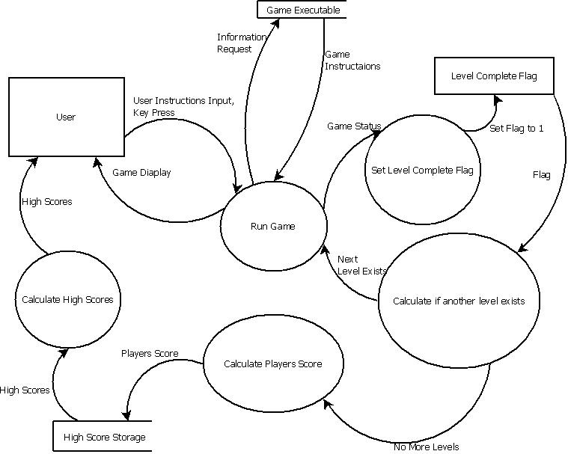
(Planning and Design | HSC Software Final, Game, 2015)

Political
Political feasibility analysis is used to predict the probable outcome of a proposed solution to a policy problem through examining the actors, events and environment involved in all stages of the policy-making process. It is one frequently used component of a policy analysis and can serve as an evaluative criterion in choosing between policy alternatives. Feasible policies must be politically acceptable or at least not unacceptable. Political unacceptability is a combination of two conditions too much opposition or too little support. One common mistake is widespread in practice that feasibility becomes a dominant criterion of preferable alternative.
(Political feasibility analysis, 2015)

Tools
This easy-to-use tool can help you analyse, understand, and create effective strategies to promote your point of view on any policy question or political issue.
PolicyMaker provides step-by-step guidance to help you conduct a stakeholder analysis and design political strategies to support your policy.
(PolicyMaker 4 Software Computer-Assisted Political Analysis, 2015)

Alternative Solutions
The first step of performing a feasibility study is to identify potential implementation alternatives for your project. Contrary to popular opinion, there are always several options for implementing an application.
Once there is a clear understanding of the business problem that the project addresses, the team needs to understand the alternative solutions available. If the goal of the project is to replace an IT system that is outdated, then the alternative solutions might include redeveloping the existing system, replacing it or merging it with another system. Only with a clear understanding of the alternative solutions to the business problem, can work on the Feasibility Study begin in earnest.
(Makar, 2012)

Potential alternatives include:
- Do nothing:
  - A valid option is to remain with the status quo and not implement an application at all.
- Build it in one or more languages:
  - There are many implementation languages that can be chosen from, including Java, C#, and COBOL. Furthermore, you can choose to work with several languages on a single project. For example, many organizations choose to use Java on client machines because of its portability and ease of distribution and COBOL for shared logic implemented on a mainframe.

- Build it using one of several technical architectures:
  - You can usually choose from several architectural strategies, including service-oriented architecture (SOA), mainframe-based with thin clients, fat-client, or application server based (e.g. J2EE).

- Buy a package and integrate:
  - Perhaps your best alternative is to choose one or more commercial-off-the-shelf (COTS) packages developed by a software company that specializes in the problem domain that you are attempting to automate. Excellent packages for human resources, manufacturing, distribution, insurance, and banking exist, to name a few.

The important thing is to identify several viable alternatives for your project so that you may assess and then compare them to select the best one for your organization.
(Ambler, 2014)

Recommendations
The final section of feasibility and recommendation reports states the recommendation. You'd think that that ought to be obvious by now. Ordinarily it is, but remember that some readers may skip right to the recommendation section and bypass all your hard work! Also, there will be some cases where there may be a best choice but you wouldn't want to recommend it. Early in their history, laptops were heavy and unreliable--there may have been one model that was better than the rest, but even it was not worth having.

The recommendation section should echo the most important conclusions leading to the recommendation and then state the recommendation emphatically. Ordinarily, you may need to recommend several options based on different possibilities. This can be handled, as shown in the examples, with bulleted lists.

In an evaluation report, this final section would state a final opinion or judgement. Yes, the free-bus-transportation program was successful, or at least it was, based on its initial expectations. No, it was a miserable flop--it lived up to none of its minimal requirements. Or, it was both a success and a flop--it did live up to some of its requirements, but did not do so in others. But in this case you're still on the hook--what's your overall evaluation? Once again, the basis for that judgment has to be stated somewhere in the requirements section.
(Online Technical Writing, 2015)

Bibliography
Agile software development. (2015, 11 10). Retrieved 11 10, 2015, from Wikipedia: https://en.wikipedia.org/wiki/Agile_software_development
Chapter 2: Key Principles of Software Architecture. (2015). Retrieved 11 16, 2015, from Microsoft.com: https://msdn.microsoft.com/en-us/library/ee658124.aspx
Feasibility study. (2015, 11 17). Retrieved 11 17, 2015, from Wikipedia: https://en.wikipedia.org/wiki/Feasibility_study
Online Technical Writing. (2015). Retrieved 11 30, 2015, from tu-chemnitz: https://www.tu-chemnitz.de/phil/english/sections/linguist/independent/kursmaterialien/TechComm/acchtml/feas.html
Planning and Design | HSC Software Final, Game. (2015). Retrieved 30 11, 2015, from http://www.coronetpublications.net/: https://mikefridhsc.files.wordpress.com/2010/03/data-flow-diagram-game.jpg
Proof of concept. (2015, 07 17). Retrieved 11 30, 2015, from Wikipedia: https://en.wikipedia.org/wiki/Proof_of_concept
Waterfall model. (2015, 11 10). Retrieved 11 10, 2015, from Wikipedia: https://en.wikipedia.org/wiki/Waterfall_model
What is Agile model – advantages, disadvantages and when to use it? (2015). Retrieved 11 10, 2015, from ISTQB EXAM CERTIFICATION: http://istqbexamcertification.com/what-is-agile-model-advantages-disadvantages-and-when-to-use-it/
What is Waterfall model- advantages, disadvantages and when to use it? (2015). Retrieved 11 10, 2015, from ISTQB EXAM CERTIFICATION: http://istqbexamcertification.com/what-is-waterfall-model-advantages-disadvantages-and-when-to-use-it/
Diggins, C. (2011, 07 24). The Principles of Good Programming. Retrieved 11 16, 2015, from Artima Developer: http://www.artima.com/weblogs/viewpost.jsp?thread=331531
Waters, K. (2007, 9 4). Disadvantages of Agile Development. Retrieved 11 16, 2015, from All about Agile: http://www.allaboutagile.com/disadvantages-of-agile-development/

